Welcome to
Kennington Pre-school



The Old School Buildings, The Avenue, Kennington, Oxford
OX1 5PP

Tel: 01865 326606
KenningtonPre-School@outlook.com
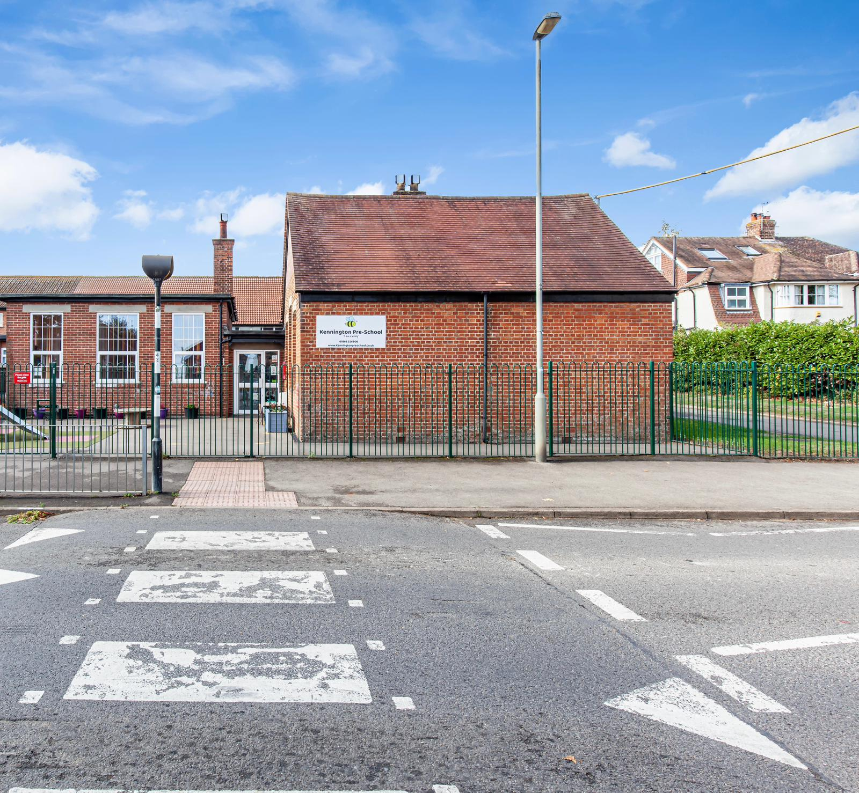

This ‘Welcome Pack’ is provided to help you and your little one to settle in at Kennington Pre-School. We understand that this can be a difficult time for parents, and we would like to support you as much as possible to make this an enjoyable experience for you and your family. We hope this covers any questions but if not please do not hesitate to ask a member of the staff team.

Welcome to our Pre-School.
Kennington Pre-school is a wonderful place for young children to learn and grow. We operate Monday to Friday 9-3pm term time only. The pre-school itself is located on the Avenue, on the grounds of St Swithuns School, although we are independent, and this is in the heart of the beautiful village of Kennington.
Kennington Pre-school has been running since 1969 (previously known as Kennington playgroup). In 2017 we became a Charitable Incorporated Organisation (CIO). We employ several qualified staff to care and teach the children on a daily basis, but the charity itself is run by a voluntary committee. Being an independent charity means that we can keep our costs low so childcare remains affordable and that we can focus on what people in our community need childcare wise.

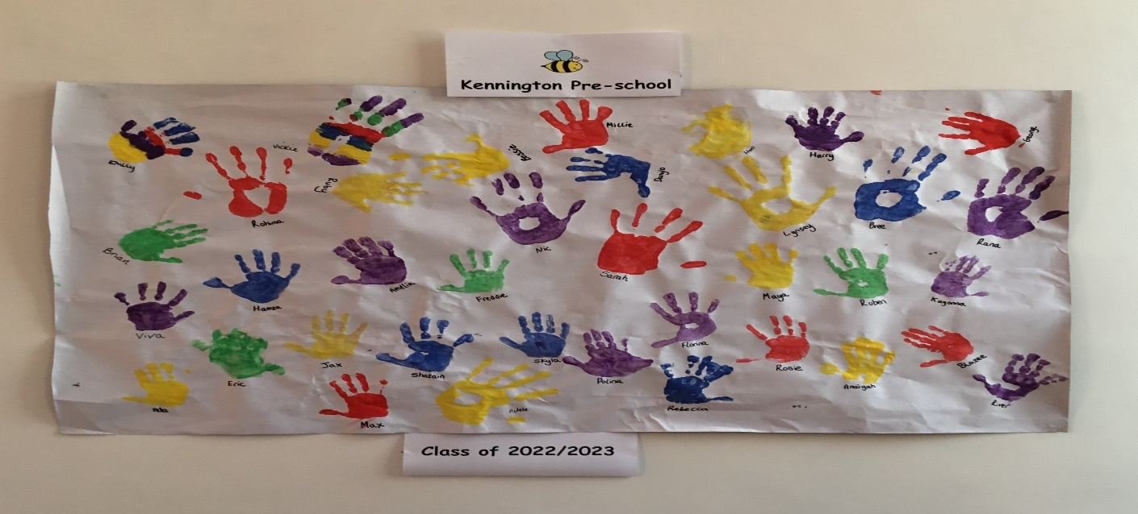
What we offer
We offer a safe and nurturing environment for children aged 2-5 years old. The staff are highly qualified and dedicated to providing the best care and education for each and every child. We follow the Early Years Foundation Stage (EYFS) guidance, which focuses on the individual needs and interests of each child. This allows the children to learn and develop at their own pace.
One of the unique aspects is our emphasis on Self reassurance. We want the children to learn that basics of feeling confident to have a go at things, to be resilient, to be kind to others and to be believe in themselves. We do this by praise, encouragement and by building strong bonds.
The pre-school has 2 large outdoor spaces, where the children have the opportunity to play and explore in a natural environment, which helps to develop their gross motor skills and appreciation for nature. We also organise regular nature walks and outdoor activities! This allows the children to learn about the world around them while having fun.
In addition to outdoor play, we also offer a variety of indoor activities. The pre-school has a well-stocked art and craft area, where the children can express their creativity and develop their fine motor skills. There is also a cozy reading corner, filled with a wide selection of books for children of all ages to enjoy. We have an amazing home corner that is a real home from home and a music area for all our budding musicians. We also offer music and movement sessions at the start of each session, which are not only fun but also help in the development of language and coordination skills.
What we stand for
We are much more than just a place for children to play. We are a nurturing setting with a stimulating environment where children can learn, grow, and develop important skills that will prepare them with the foundation for their future educational journey.
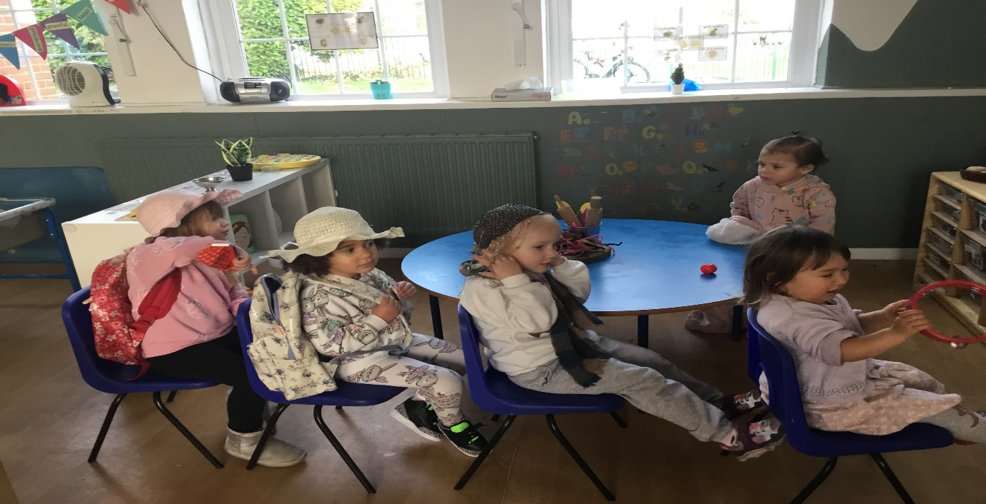
Our Opening Hours
We offer the following sessions Monday to Friday during the term time:
Morning Session 9-11:45
Lunch 11.45-12:15
Afternoon Session 12:15-3pm

Our Staff
We have a fantastic team of Practitioners who are passionate, committed, caring and have a loving approach to childcare which is clear in the relationship between the children and staff. We ensure all staff within the setting are in receipt of an enhanced DBS check and are trained in safeguarding and hold a first aid qualification.
The staffing ratio is as following:
2 - 3 years: 1 Practitioner per 5 children
3 - 5 years: 1 Practitioner per 8 children


Our committee
Kennington Pre-School is a registered charity with is run by a committee of parents/carers and volunteers.
The committee is responsible for the overall running of the Preschool, including fund raising, policy updating, and general decision making. We cannot exist without a committee; they are the management and the employers.
We ask all parents/carers to join the committee, and to take part as much or as little as they wish.
If you would like to come along to a committee meeting, please contact Katie Whelan- Matthews at kpgchair@hotmail,com

STARTING WITH US
A child who is tense or unhappy will not be able to play or learn properly, so it is important for the staff to work together with parents to help your child to feel secure and confident in the group. Parents should not feel worried if their child takes a while to settle, as some children take longer than others.
Parents will be invited to come with their children for 2 one hour settling in sessions. This will be a chance to meet your child’s allocated key person, and to discuss any concerns you may have and also how best to get your child settled at the start.
Once your little one starts parents can phone the setting for an update on how their child is getting on.
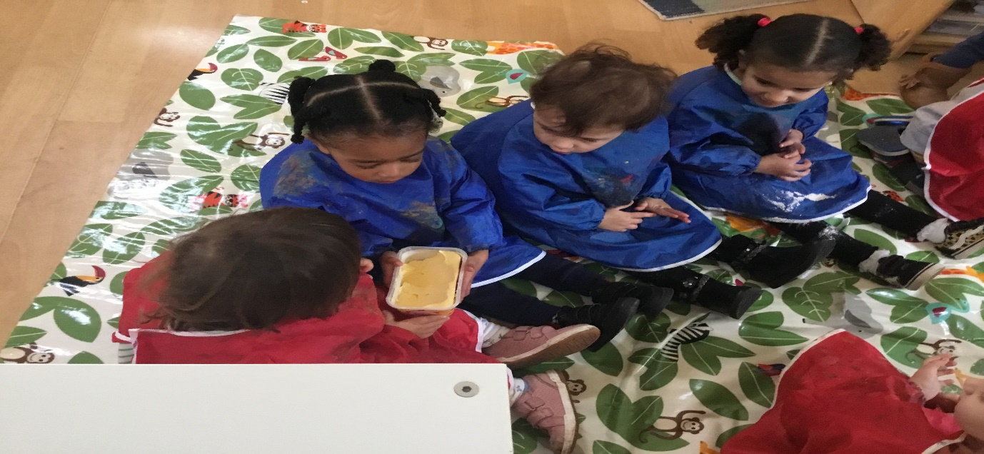
Key person Approach
Our setting uses a key person approach. This means that each member of staff has a group of children for whom they are particularly responsible.
Your child’s key person will be the person who works with you to make sure that the childcare we provide is right for your child’s particular needs and interests.
Although you are welcome to speak to any member of staff your Key Person will be the one to track your child’s development.

Child Profiles/Assessment
Play helps young children to learn and develop through doing and talking, which research has shown to be the means by which young children learn to think.
Our setting uses the Development Matters in the Early Years Foundation Stage guidance to plan and provide a range of play activities, which help children to make progress in each of the areas of learning and development.
In some of these activities, children decide how they will use the activity, and, in others, an adult takes the lead in helping the children to take part in the activity. In all activities, information from Development Matters in the Early Years Foundation Stage has been used to decide what equipment to provide and how to provide it.
We assess how young children are learning and developing by observing them frequently. We record this information using Evidence me which allows us to share this information with parents at the click of a button. We use information that we gain from observations, as well as from photographs or videos of the children, to document their progress and where this may be leading them.
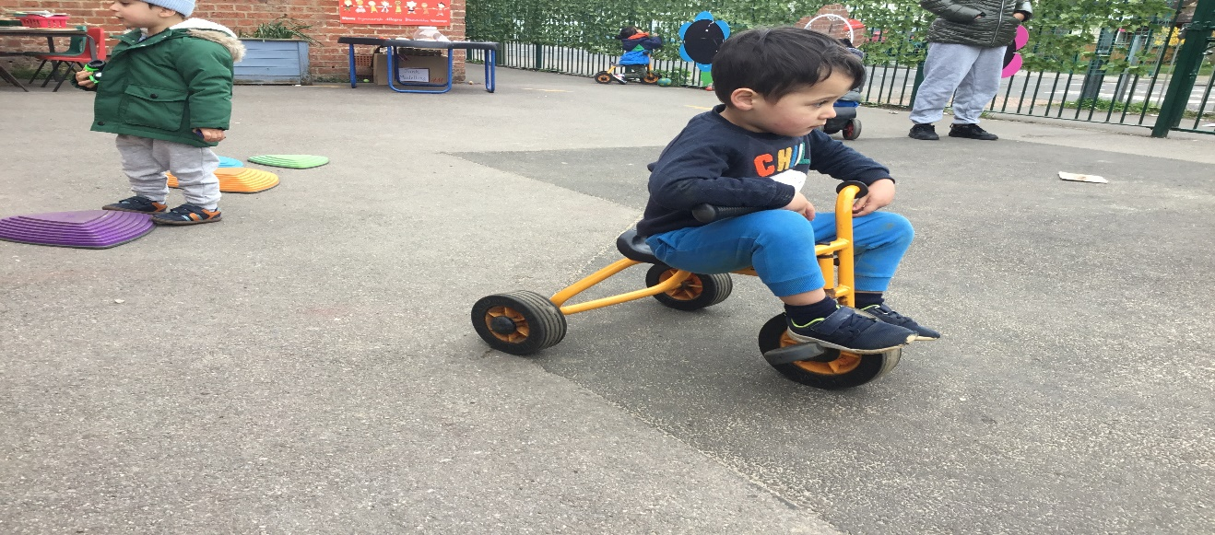
2 Year Checks
In addition to the above the Early Years Foundation Stage requires that we supply parents and carers with a short-written summary of their child’s development in the three prime areas of learning and development (personal, social and emotional development; physical development; and communication and language) when a child is aged between 24 - 36 months. Your Key Person will discuss this at Parents evening.
Parents Evenings
These happen twice a year (April and November). Your Keyworker will arrange a time to meet either face to face or online to discuss your Child and their development. This is also a good chance for you to ask any questions you might have.
Additional Educational Needs
We encourage each child to progress and develop at their own rate in all areas of their development.
Children with additional needs and or learning difficulties are supported at Preschool by the SENco and by the key worker. We work closely with parents and will liaise with other professionals, outside the setting to help your child progress.
If you would like to discuss any worries or concerns you may have about your own child’s additional needs or our ability to meet those needs, please talk to our Special Educational Needs co-ordinator (SENco).

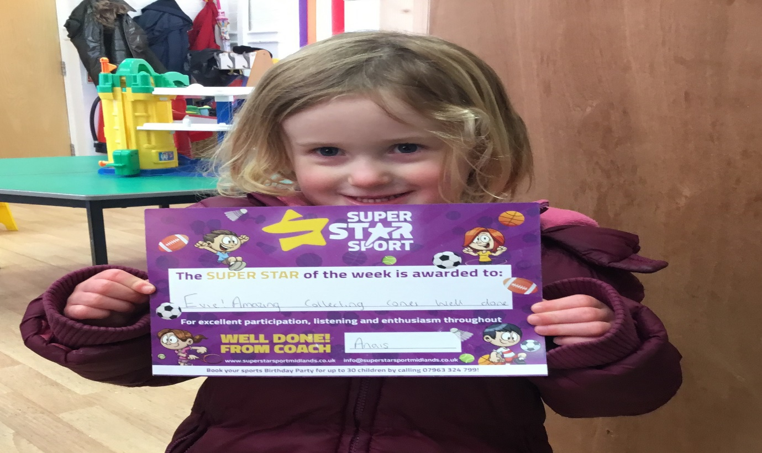
What to bring
We ask that the children to dress for mess! Old clothes as perfect for Pre-School!
Named Water Bottle: We also provide milk or water at snack times. We refill water bottles throughout the day for children.
Weather appropriate clothing: A waterproof coat. Wellington boots. Warm hat in winter and summer hat in Summer. Again, all named.
Spare clothes: At least 2 tops and 3 pairs of underwear, socks, and bottoms if your child is toilet training - Crocs/Jelly shoes can be a good alternative to shoes or wellies whilst toilet training to allow them to be cleaned and dry quickly.
Nappies, Wipes and Cream: A supply of nappies is essential along with your own wipes. If you wish for nappy cream to be applied, please provide a named pot/tube in your child’s bag. We ask you to avoid pull ups unless your child is in the process of potty training.
Sun cream: In the summer we ask for all children to arrive to nursery with sun cream already applied and if they are staying for a full day session we ask for a bottle in their bag, to allow it to be reapplied in the afternoon.

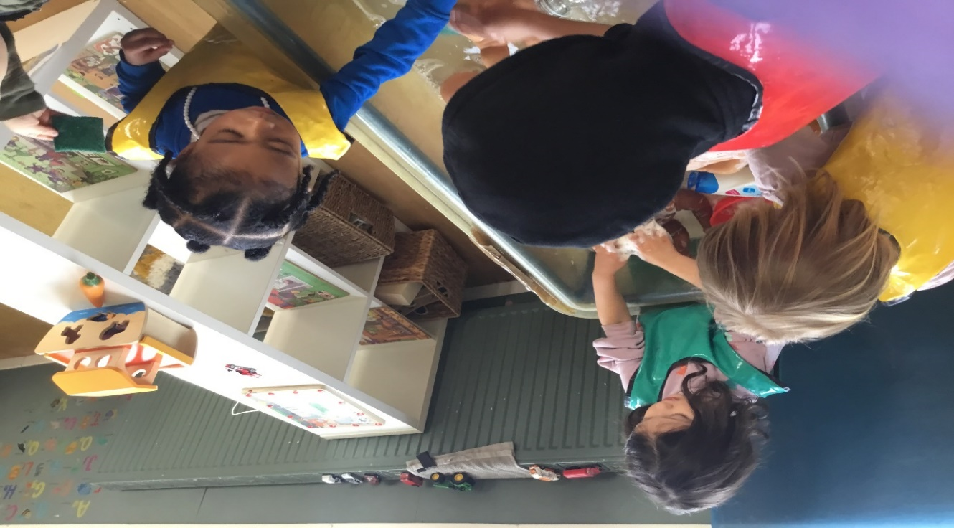
Daily routine
Preschool begins at 9am for a morning session and 12.30pm for an afternoon session. On arrival the children are encouraged to self-register by finding their picture and placing it on a peg. When all the children have arrived, me ring the bell to sit down on the carpet to welcome everyone and to discuss our mornings and how we are feeling that day. After this the children are free to choose their own activities from the wide selection on offer (following the EYFS). Activities are also available outside.
Snack will be available from 9:30am (supplied) we offer a choice of fruit/Vegetables, and one carbohydrate, milk, or water.
Child initiated activities continue all session along with a planned activity such as cooking, craft, painting, science experiments or play games.
Fifteen minutes before the end of the session the bell sounds and all children and staff stop what they are doing to help tidy up. This is followed by group discussions, stories, and song time. At the end of the session the children staying for lunch club are taken to wash their hands and sit down for lunch while the remaining children get coats and bags to go home.

Parking

There is no parking available within the grounds. There is limited parking around the school on the surrounding streets, so we recommend where possible to walk and cycle We do ask you to choose a space carefully and to avoid blocking sight-lines at corners and crossing points, and not to block the driveways of local residents.

Parking is also available at St Swithun's Church on The Avenue if required for drop off and pick up.
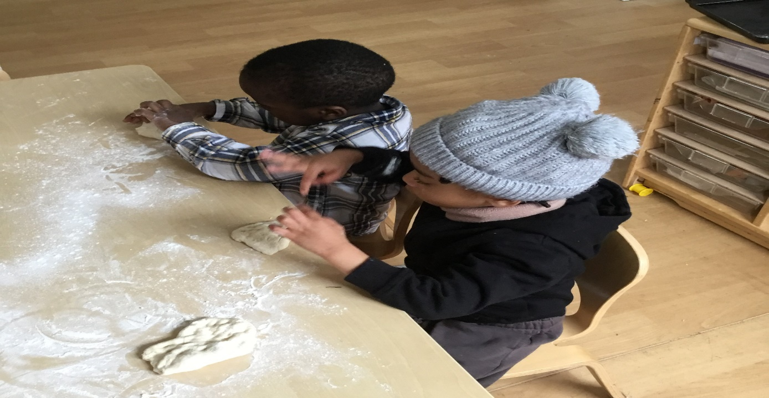

Illness
Your child is not able to come to Pre-School if:
They are unwell,
Have had Calpol,
Or are displaying symptoms of contagious illness.
If they become unwell during the day, we will ask for them to be collected as soon as possible. Please see our Sickness and Illness policy for more information.
Returning to nursery If your Child has been sent home from the nursery because of ill health, means he/she will not be re-admitted for at least 24 hours.
If a child is sent home with a temperature, they will not be re-admitted for at least 48 hours after the temperature has subsided.
If the Child is prescribed antibiotics, he/she will not be allowed to return to the nursery for 24 hours after the antibiotics course has been started.
Please be aware a 48-hour exclusion also applies to cases of sickness, diarrhoea from the last episode.
Fees remain payable during absences including sickness.
We ask that you call or email us to let us know that you won't be able to be attending.

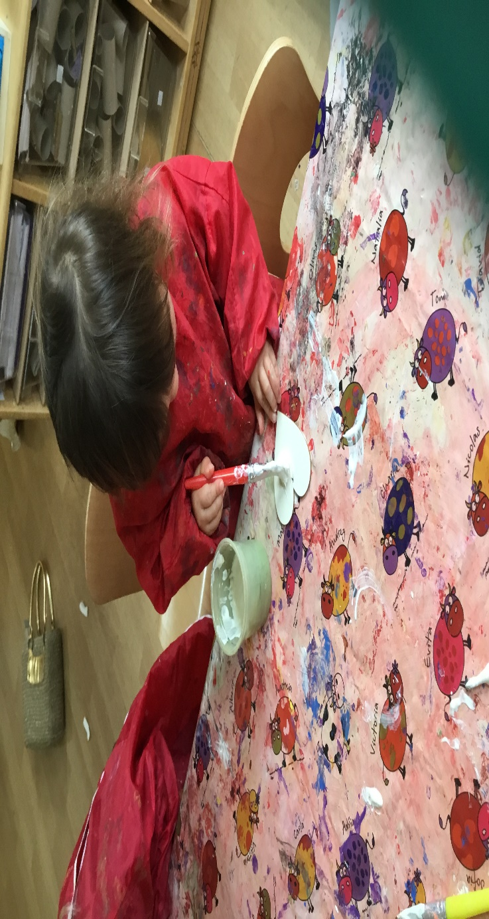
Fees
Invoices are processed at the start of each calendar month for the whole month. You will receive your invoice via Interactive Nursery Manager, and it must be paid within 30 days. Fees are payable by cash or BACs. If you fail to pay us on time and haven’t spoken to management, we may suspend all sessions for your child until payment has been made in full.
If payment is delayed by 60 days or more, we may also charge you reasonable costs of seeking to recover the overdue payments.
Our current fees are:
Morning Session (9-11.45) £22
Lunch Session (11.45-12.15) £6 (optional Hot meal £2.80)
Afternoon Session (12.15-3) £22
Snack and cooking fee £2 a day
Late Fees £5 per 5 minutes if not pre-notified
Late payment (more than 30 days late) £25
Late Payment (more than 60 days late) £50 plus court fees

Funded Spaces
We currently take children who qualify under the government funding scheme for 15hours and 30 hours. Funded sessions can be used for morning, lunch (hot meal is an optional extra) and afternoon sessions.

We cant always accommodate the full funded hours due to staff and children ratio however will always do our best to accommodate your needs and we are also happy to share funded hours with another provider.

To help us maintain our current offering, we ask all parents to contribute a voluntary contribution. We have two levels of contribution to make it easier to understand:

Basic contribution: £2 a day to cover snack, nappies and cooking fees, these are added to your invoice and can be removed at any time

Enhanced Contribution: £5 a day covers all of the above and also helps to cover the rising costs of Trips, Forest School, outside activities from external companies, cleaning supplies, rental costs and much more. This can also be added and removed at any time

Our current Charges NOT covered by funding:
Late Fees £5 per 5 minutes if not pre-notified
Late payment (more than 30 days late) £25
Late Payment (more than 60 days late) £50 plus court fees
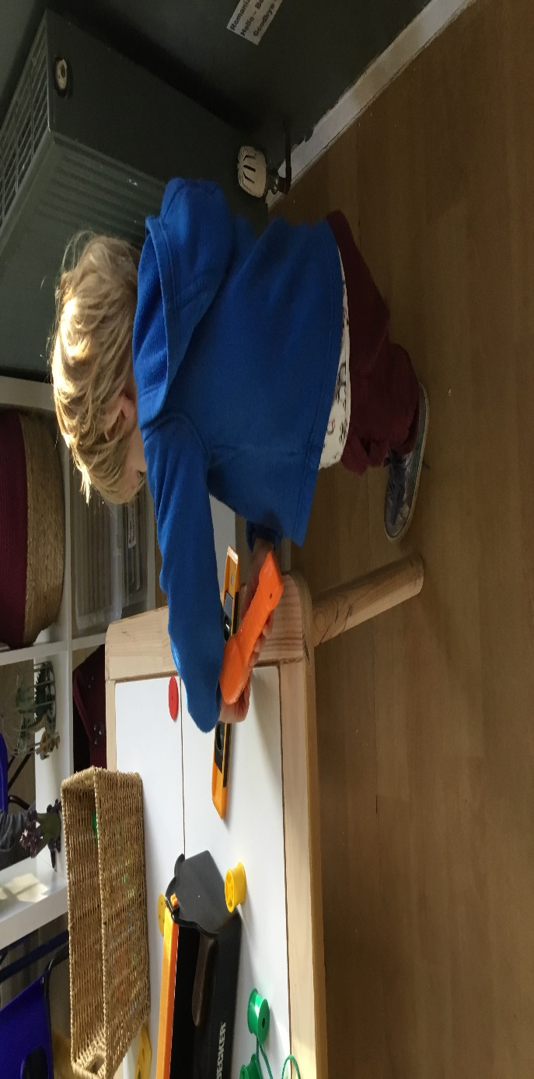
Extra activities
We want the children in our care to have the best opportunities and to make memories during there time with us. To make this experience as enjoyable as possible we pay for other professionals such as sports coaches and yoga to come into the setting on a weekly basis as well as visiting Forest School.
These groups happen on at a different session each term, so all children get a chance to experience this at some point during the school year.

Safeguarding
Your children are the most important things to us, and we want to make sure we are safe and secure while in our setting. Please remember to let your Keyworker know in someone other than the usual parent/carer is collecting your child from Pre-school and ensure they are aware of the Password you have set.

Leaving Pre-school
We hate to think of any of our children moving on, but we understand that circumstances change and that sometimes parents are left with the difficult decision of having to move settings.
Our notice period on non funded hours is 6 Weeks’ notice in writing (this does not include school holidays).
There is not a notice period on funded hours.
When a child moves on, we ask that you tell us where you are moving them to, so we can send over transition reports and speak you the new keyworker. In our experience this makes the move much easier for everyone.

School Lunches

SCHOOL MEALS: This is recommended and our most popular option for all children at the cost of £2.80 a day. The food is provided freshly made by the Abingdon Learning Trust and is prepared in accordance with Department of Education guidelines, This is a great for children to explore new foods and, they are also experienced in food allergy preparation. A menu is provided each term where you can select a hot meal or a Deli option,
PACKEDED LUNCH: From September 2025 the government have introduced nutritional guidelines that we as an early years setting will be following.
If providing a packed lunch, parents must cover all 4 food nutritional food groups and ensure the food is chopped and prepared correctly, This also means Children will not be allowed to have more than one packet of crisps or chocolate in their lunch box once a week. To monitor this Pre-school are now required to check lunch boxes prior to lunch and if the this is not considered to cover the guidelines, parents will need to return and replace the items or collect children for lunch. In addition to this, all lunch boxes and the contents will need to be individually named each day to avoid contamination.
We appreciate this is not ideal however, this has been introduced and ALL settings with children under 5 must follow. We therefore recommend that parents choose the school meals for ease.

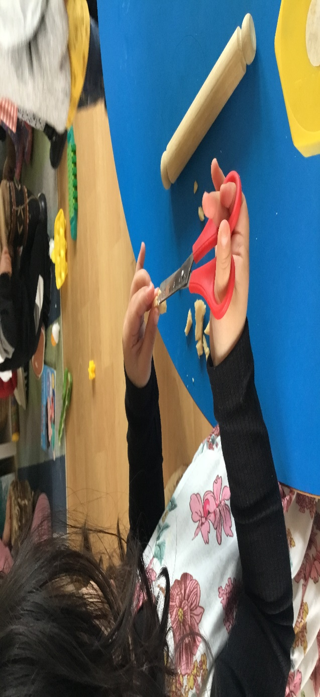
Communication
Good communication between the home and the setting is essential for the children’s wellbeing. We communicate in the following ways:
Pre-school communication emails
Kennington Pre-school website – This is where you will find our term dates and copies of Policies and Procedures.
Facebook (Kennington Pre-school)
Famly App – This is what we use to track development (an invite with be emailed to you) this is also used for Invoices and where we document relevant information such as sessions, allergies, and permissions (an invite will be emailed to you)
Abingdon Learning– We offer fresh hot meals at an additional cost of (currently) £2.80pp this is optional, but you will be given a login to order each term.

What happens now?
You shortly contact you with details of your settling in sessions along with the official start date and the name of your Keyworker. We also ask you to bring in your registration documents, Childs ID and red book to the first visit.

